What happens to our bodies after we die?

By: Farnaz Khatibi Jafari
https://tinyurl.com/death206

- Over the course of history, an estimated 100.8 billion people have died. (1)
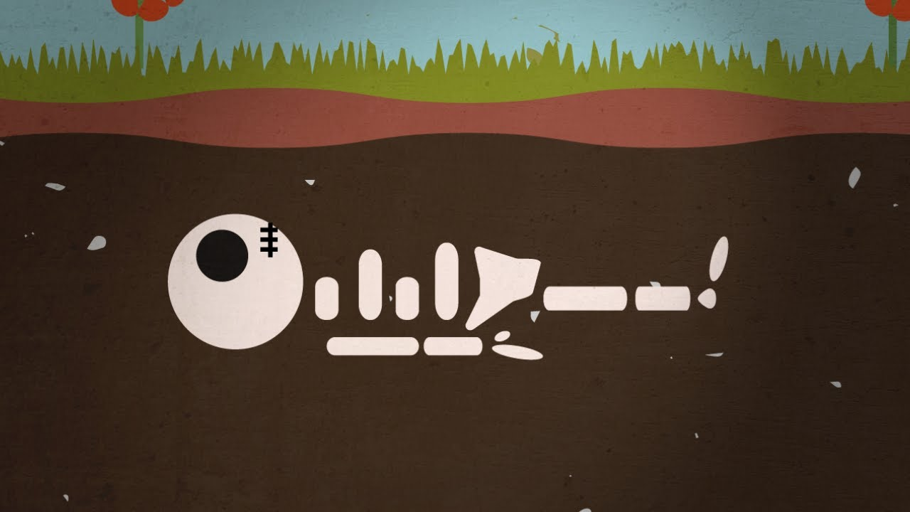
- The number of people who have died increases to what percent of the world’s population every year? (1)
  - .10
  - .15
  - .8
  - .5
- Post-mortem stain is called: (1)
  - Algor mortis
  - Livor mortis
  - Rigor mortis
  - Primary flaccidity
- Rigor mortis can be affected by _______________, _______________ and the surrounding environment. (2 points)
- Based on the Casper's Law, a body exposed to ______ decomposes twice as fast as one immersed in _______ and 8 times as fast as one buried in ________. (3 points)
  - Water; air; soil
  - Air; water; earth
  - Air; soil; water
  - Soil; water; air
- Different cultures throughout history have developed unique approaches to burials. Death was accompanied by ____________. (1 point)
- What is the second most common burial method? (1)
  - Soil internment
  - Burying in biodegradable caskets
  - Cremation
  - Promession
- Most of the big cities in the world may run out of suitable burial grounds within a ______________________ (1 point).
- Name two alternatives to traditional burials that might help with the space issue? (2)

